

**#NO PRO RACE**

**SAILING INSTRUCTIONS**

**16.03.2025 Stage 7**

*The notation ‘[DP]’ in a rule in the SI means that the penalty for a breach of that rule may, at the discretion of the protest committee, be less than disqualification.*

# 1. RULES

**1.1.** The regatta will be governed by the rules as defined in The Racing Rules of Sailing (RRS 2021- 2024)

**1.2.** No national prescriptions will apply

**1.3.** The Far East 28 R class rules will apply

**1.4.** If there is a conflict between languages the English text will take precedence.

1.5. In case of conflict between the FAREAST 28R Class Rules, the Notice of Race, the Sailing Instructions, the Sailing Instructions will take precedence. In case of conflict between the FAREAST 28R Class Rules and the Notice of Race, the Notice of Race will take precedence. If there is a conflict between Notice of Race and Sailing Instruction the sailing instructions takes precedence. This changes RRS 63.7

# 2. NOTICES TO COMPETITORS

Notices to competitors will be posted on the official telegram chat https://t.me/ciscchat

# 3. CHANGES TO SAILING INSTRUCTIONS

Any change to the sailing instructions will be communicate to competitors at the skkiper’s meeting.

# 4. SIGNALS MADE ASHORE

**4.1** When flag AP is displayed ashore, ‘1 minute’ is replaced with ‘not less than 45 minutes’ in the race signal AP.

# 5. SCHEDULE OF RACES 5.1. Program

|  |  |  |
| --- | --- | --- |
| |  | | --- | | **No Pro + fleet**  9:00 Registration, briefing  9:30 Exit from marina  10:00 Start of races  13:00 award ceremony | |  |
| |  | | --- | | **No pro fleet**  13:00 Briefing  13:30 Exit from marina  14:00 Start of races  17:00 Award ceremony | |  |

**5.2.** Number of races

It is intention of the Race Committee to have three (3) races for each fleet.

**5.3.** For **No pro + fleet** no warning signal will be made after 12:30

For **No pro fleet** no warning signal will be made after 16:30

.

**6. CLASS FLAG**

The class flag is a white flag with the Far East 28R insignia

# 7. RACING AREA

The racing area is in the Limassol bay.

# 8. THE COURSES

**8.1.** The diagrams in Attachment B show the courses, including the approximate angles between legs, the order in which marks are to be passed, and the side on which each mark is to be left.

**8.2.** No later than the warning signal, the race committee signal vessel will communicate the approximate compass bearing of the first leg.

**8.3.** Unless communicated before the warning signal the course to be sailed is W2

# 9. MARKS

**9.1.** Marks 1 are yellow cylindrical inflatable

**9.2.** The starting and finish mark are yellow cylindrical inflatable

# 10. AREAS THAT ARE OBSTRUCTIONS

The swimming area, which is marked with round pink or orange marks located alongside the beach, is considered restricted area and a boat may be protested and disqualified if entering that area.

# 11. THE START

**11.1.** The starting line will be between a staff displaying an orange flag on the Committee boat at the starboard end and a starting mark on the port side of the line.

**11.2.** A boat that does not start within 4 minutes after her starting signal will be scored Did Not Start (DNS) without a hearing. This changes RRS A4 and A5.

# 12. CHANGE OF THE NEXT LEG OF THE COURSE

To change the next leg of the course, the race committee will move the original mark (or the finishing line) to a new position

# 13. THE FINISH

The finishing line will be between staff displaying a blue flag on the Committee boat and a Start mark.

# 14. TIME LIMITS AND TARGET TIMES

**14.1.** Time limits and target times for the first boat are as follows:

|  |  |  |
| --- | --- | --- |
| TIME LIMIT FOR MARK1 **20 min** | TARGET TIME **25 min** | RACE TIME LIMIT **50 min** |

**14.2.** If no boat has passed Mark 1 within the Mark 1 time limit the race will be abandoned.

**14.2.** Failure to meet the target time will not be ground for redress. This changes RRS 62.1(a).

**14.3.** Boats failing to finish within 10 min after the first boat sails the course and finishes will be scored Did Not Finish (DNF) without a hearing. This changes RRS 35, A4 and A5.

# 15. PROTESTS AND REQUESTS FOR REDRESS

**15.1.** Protest forms are available at the race office, located at the stand in TGI “Friday’s” restaurant veranda. Protests and requests for redress or reopening shall be delivered there within the appropriate time limit

**15.2.** The protest time limit is 60 minutes after the last boat has finished the last race of the day or the race committee signals no more racing today, whichever is later.

**15.3** Protest fee 100€

# 16. SCORING

PART A SERIES SCORING

**16.1.** One (1) race is required to be completed to constitute a stage.

# 17. REPLACEMENT OF CREW OR EQUIPMENT

**17.1.** Substitution of competitors will not be allowed without prior written approval of the race committee.

**17.2.** There is no limitation on the number of the crew members or the maximum total crew weight during any day of the event. (This changes class rule C3.2)

**17.3.** Substitution of damaged or lost equipment will not be allowed unless authorized by the race committee. Requests for substitution shall be made to the committee at the first reasonable opportunity.

1. **EVENT ADVERTISING**

Boats shall display event advertising supplied by the organizing authority.

1. **RADIO COMMUNICATION**

Radio communication is on VHF channel 72

# 20. DISCLAIMER OF LIABILITY

Competitors participate in the regatta entirely at their own risk. See RRS 4, Decision to Race. The organizing authority will not accept any liability for material damage or personal injury or death sustained in conjunction with or prior to, during, or after the regatta.

# 21. MALFUNCTION OF EQUIPMENT

In case of malfunction or damage the competitor needs to notify the organizing authority. The organizing authority will make reasonable effort to repair it before the start of the next race. The protest committee will not examine any request of redress for damages or malfunctioning of the boats that occurs after the start of the first race of day.

# 22. THE USE OF SPINNAKER

When the average wind speed increases above 15 kts the race committee will communicate via VHF the command “spinnaker off”. The boats are not allowed to hoist the spinnaker.

Failure to comply will result in a DSQ without a hearing. This changes RRS 63,1 and A5. When the average wind speed decreases below 15 kts the race committee may communicate via VHF the command “spinnaker restored”. The boats are allowed to use their spinnakers.

# 23.PRIZES

Prizes will be given as per the Notice of Race

**ATTACHMENT A**

**Racing area**

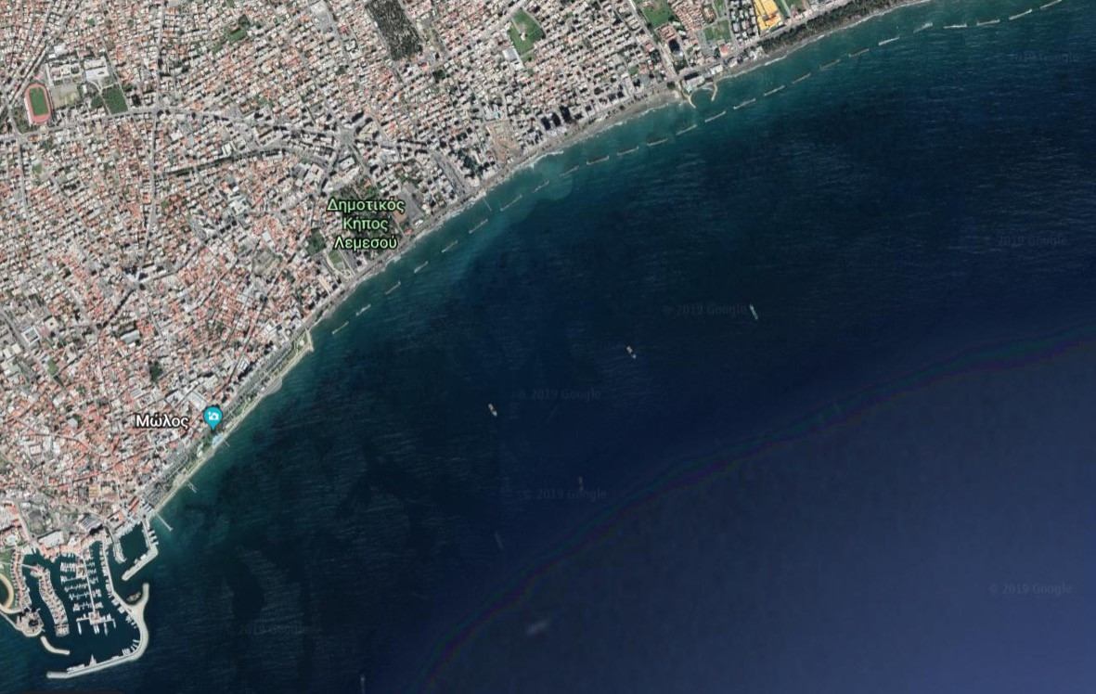

**ATTACHMENT B**

**The Courses Diagram**

1

Start

Committee boat

S

Finish

|  |  |  |  |  |  |  |  |
| --- | --- | --- | --- | --- | --- | --- | --- |
| |  | | --- | | **COURSE** | | W1 | | W2 | | |  | | --- | | **DESCRIPTION** | | Start, Mark 1, Finish | | Start, Mark 1, S mark or Committee boat, Mark 1, Fininsh | |

**APPENDIX C**

BOATS PROVIDED BY THE ORGANIZING AUTHORITY

# BOATS

**C.1.** Boats will be provided for all competitors, who shall not modify them or cause them to be modified in any way except that

1. a compass may be tied or taped to the hull or spars;
2. wind indicators, including yarn or thread, may be tied or taped anywhere on the boat;
3. hulls, centerboards and rudders may be cleaned, but only with water;
4. adhesive tape may be used anywhere above the water line; and
5. all fittings or equipment designed to be adjusted may be adjusted, provided that the class rules are complied with.
   1. All equipment provided with the boat for sailing purposes shall be in the boat while afloat.
   2. The penalty for not complying with one of the above instructions will be disqualification from all races sailed in which the instruction was broken.
   3. Competitors shall report any damage or loss of equipment, however slight, to the organizing authority’s representative immediately after securing the boat ashore. The penalty for breaking this instruction, unless the protest committee is satisfied that the competitor made a determined effort to comply, will be disqualification from the race most recently sailed.
   4. Class rules requiring competitors to be members of the class association will not apply.